DSA210 Final Report

Analyzing Instagram Influencer Engagement

Sıla Öztürkler-32644

1. Introduction
Instagram is one of the most popular social media platforms today. Influencers use Instagram to share content and interact with their followers. Because Instagram provides measurable data such as likes, followers, and engagement rates, it is suitable for data analysis.
In this project, Instagram influencer data was analyzed using data science techniques. The project focuses on understanding the relationship between follower count, likes, engagement rate, and influencer popularity.
Different visualization methods and machine learning models were used to examine influencer engagement patterns and audience interaction.

2. Motivation
Social media has become an important part of daily life and digital marketing. Many companies and brands work with influencers to reach larger audiences and increase interaction with users.
I am personally interested in content creation and social media engagement. I also want to work in the field of digital marketing in the future, which made this project especially interesting for me.
Because of my interest in influencer culture and online audience behavior, I wanted to better understand what affects engagement on Instagram. Metrics such as likes, followers, and engagement rates can help explain how audiences react to influencer content.
I chose this project because Instagram provides measurable and interesting real-world data for analysis. This project also allowed me to combine my personal interests with data science and machine learning techniques while exploring influencer engagement behavior.

3. Dataset and Data Collection
The dataset used in this project was taken from Kaggle. It contains Instagram influencer statistics collected from publicly available sources.
Dataset link:
https://www.kaggle.com/datasets/wardabilal/global-instagram-influencers-ranking-dataset
The dataset includes information about influencers such as:
- follower count
- average likes
- engagement rate
- total likes
- number of posts
- influence score
- country information
The dataset was imported into Python and analyzed using Pandas and other data science libraries.
Before the analysis, several preprocessing steps were applied:
- missing values were removed
- duplicated rows were checked
- percentage values were converted into numerical format
- values such as “k”, “m”, and “b” were converted into numbers
- These preprocessing steps helped prepare the dataset for visualization and machine learning analysis.

4. Exploratory Data Analysis(EDA)

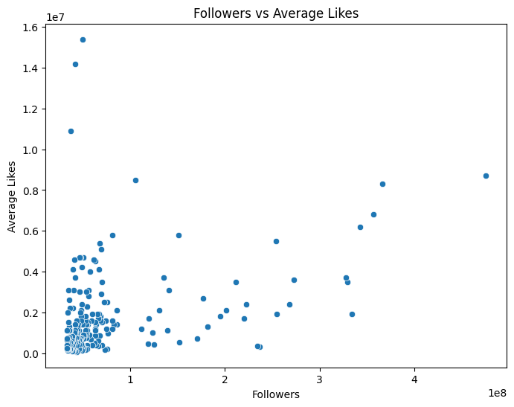

Figure 1. Relationship between follower count and average likes.
The graph shows that influencers with higher follower counts generally receive more likes.

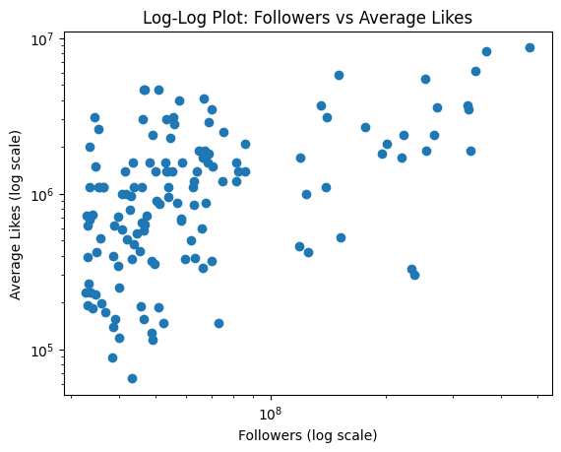
Figure 2. Log-log relationship between follower count and average likes.

Figure 3. . Correlation heatmap between numerical variables.
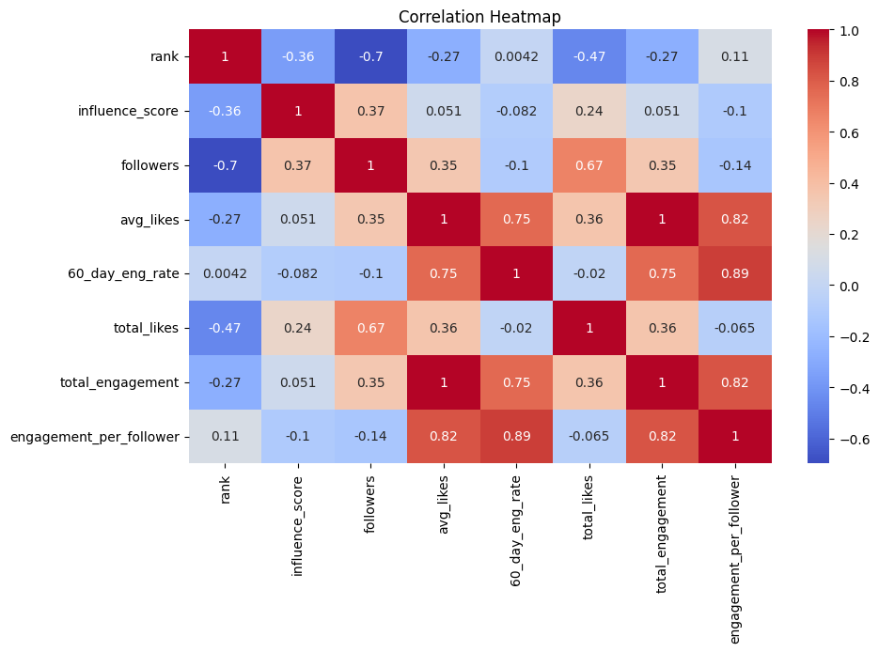
The heatmap shows the relationships between engagement-related variables. Positive correlations were observed especially between average likes, total engagement, and engagement rate.

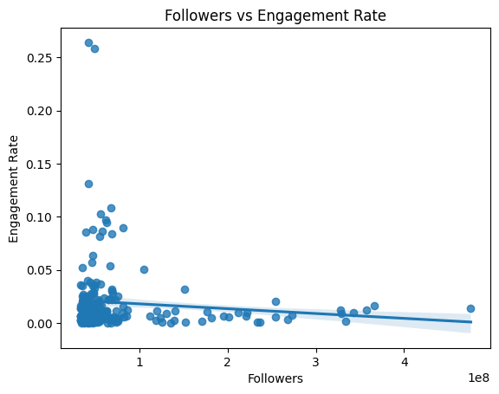

Figure 4. Relationship between follower count and engagement rate.
The graph shows that engagement rate does not always increase with follower count. Some influencers with smaller audiences have higher engagement rates.

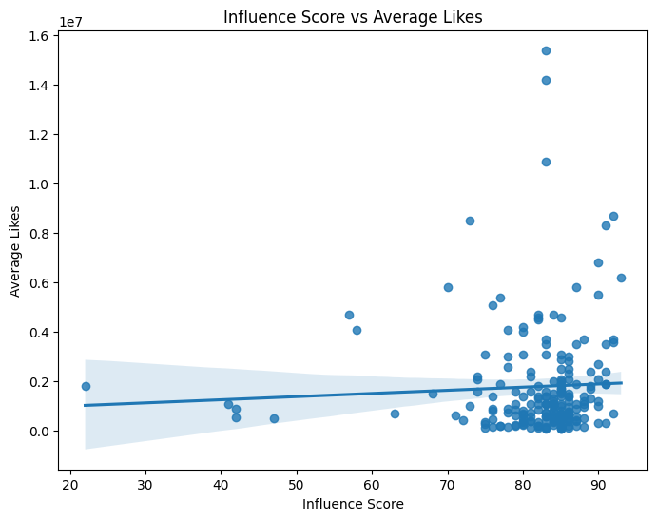

Figure 5. Relationship between influence score and average likes.
Influencers with higher influence scores generally receive more average likes and audience interaction.
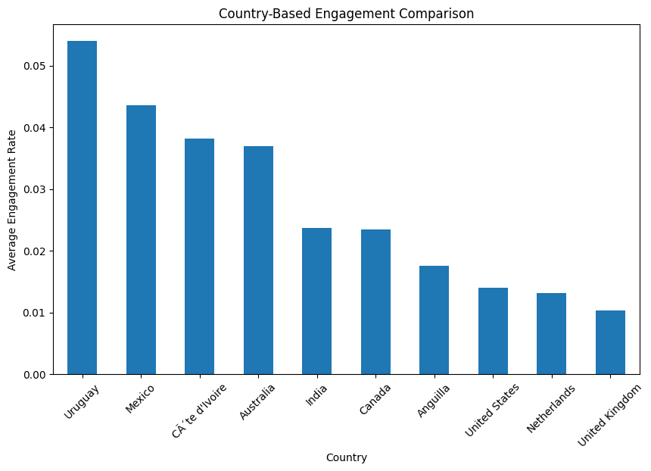

Figure 6. Country-based comparison of engagement metrics.
The visualization shows that engagement levels may vary between countries and influencer audiences.

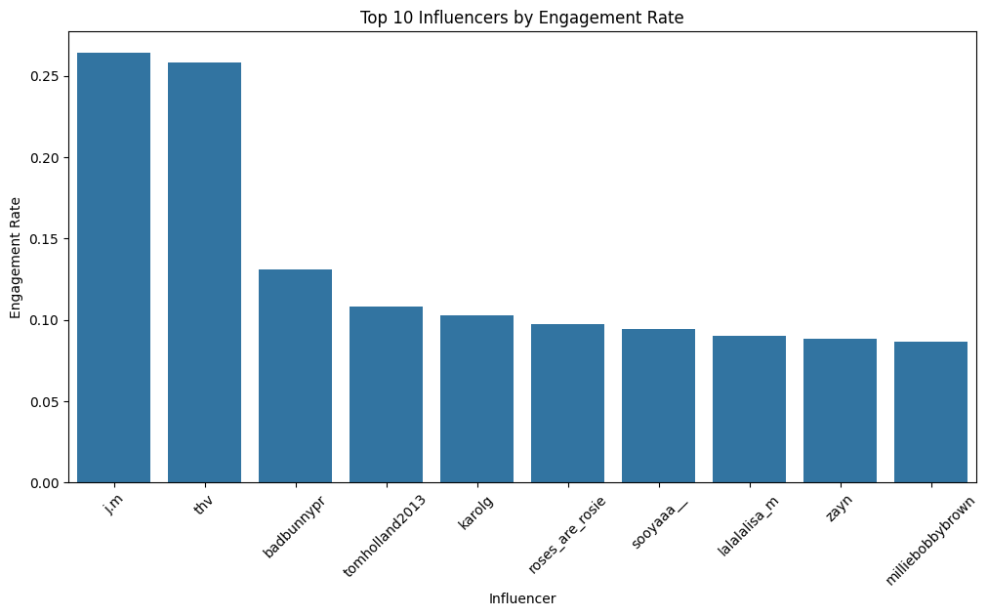

Figure 7. Influencers with the highest engagement values.
Some influencers achieve very high engagement despite differences in follower count and popularity.

In the exploratory data analysis stage, different visualization and statistical analysis techniques were used to better understand the dataset.
First, the relationships between follower count, average likes, engagement rate, and influence score were examined using scatter plots and correlation analysis.
A correlation heatmap was created to observe the relationships between numerical variables. The heatmap showed that some engagement-related variables had positive correlations with each other.
Different visualizations were also used to compare influencer engagement patterns. For example:
- follower count vs average likes
- follower count vs engagement rate
- influence score vs average likes
- country-based engagement comparison
The analysis showed that influencers with higher follower counts generally receive more likes, but engagement rate does not always increase with follower count. Some smaller influencers were observed to have stronger audience interaction.
These visualizations helped better understand engagement behavior and interaction patterns on Instagram.

5. Machine Learning Analysis
After the exploratory data analysis, machine learning models were used to better understand and predict Instagram engagement behavior.
In this project, two different regression models were used:
- Linear Regression
- Random Forest Regression
The models were trained using variables such as:
- follower count
- average likes
- engagement rate
- total likes
- number of posts
The dataset was divided into training and testing sets before the models were applied.
Linear Regression was used to observe the general relationship between variables, while Random Forest Regression was used to better capture more complex patterns in the dataset.
The prediction results were visualized using an actual vs predicted engagement graph. In addition, feature importance analysis was performed to identify which variables contributed most to engagement prediction.The machine learning analysis showed that variables such as average likes, total likes, and follower count play an important role in explaining engagement behavior.
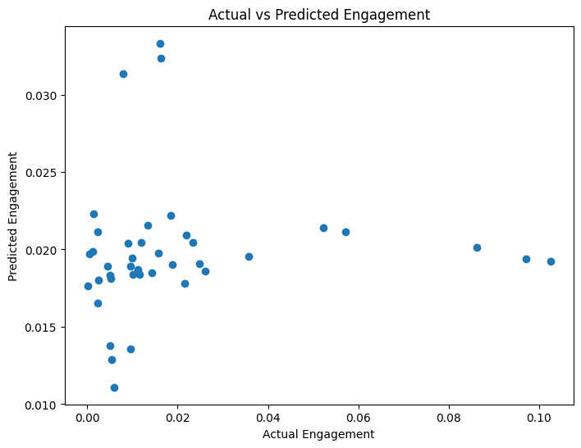
Figure 8. Actual vs predicted engagement values.
The graph shows that the machine learning model was able to capture general engagement patterns in the dataset.

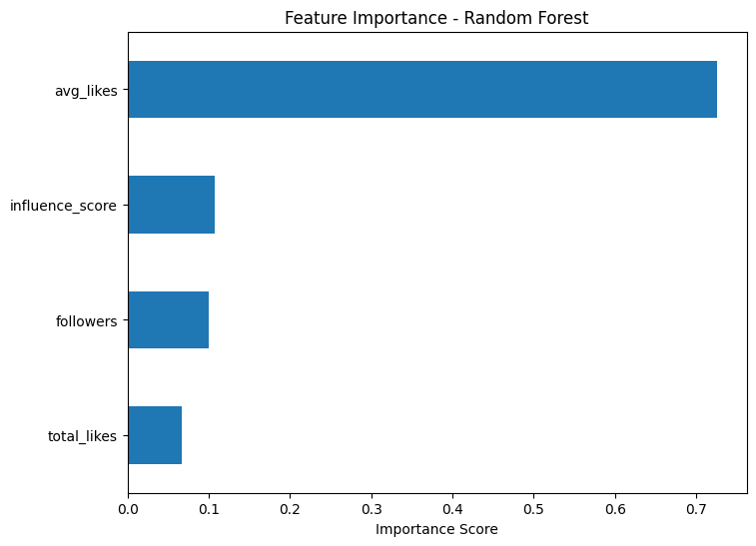
Figure 9. Feature importance analysis.
The analysis shows that variables such as average likes and total likes contribute strongly to engagement prediction.

6. Hypothesis Testing
Three main hypotheses were tested to better understand the relationships between Instagram engagement variables.

Hypothesis 0

H0: There is no significant relationship between follower count and average likes.

H1: There is a significant relationship between follower count and average likes.

The analysis showed a positive relationship between follower count and average likes. Influencers with higher follower counts generally received more likes.

Therefore, the null hypothesis was rejected.

Hypothesis 1

H0: Engagement rate has no significant relationship with follower count.

H1: Engagement rate has a significant relationship with follower count.

The analysis showed that engagement rate does not always increase with follower count. Some smaller influencers achieved higher engagement rates compared to larger accounts.

Therefore, the relationship appeared relatively weak.

Hypothesis 2

H0: Influence score has no significant relationship with average likes.

H1: Influence score has a significant relationship with average likes.

The analysis showed a moderate positive relationship between influence score and average likes.

Therefore, the null hypothesis was rejected.

7. Results and Findings

The analysis showed that follower count, average likes, and engagement rate are related to each other, but the relationship is not always perfectly linear.
One of the main findings of the project was that influencers with higher follower counts generally receive more likes. However, higher follower counts do not always guarantee higher engagement rates.
The visualizations also showed that some influencers with smaller audiences can achieve stronger audience interaction and engagement.
The correlation analysis suggested positive relationships between several engagement-related variables, especially between average likes and engagement metrics.
The machine learning models were able to capture general engagement patterns in the dataset. Feature importance analysis showed that variables such as average likes, total likes, and follower count contribute significantly to engagement prediction.
Overall, the results suggest that Instagram engagement depends on multiple factors and cannot be explained only by follower count.

8. Limitations and Future Work
This project has some limitations. First, the dataset contains a limited number of influencers and may not fully represent all Instagram users or content categories.
In addition, engagement on social media can be affected by many external factors such as trends, content quality, audience preferences, and posting time. These factors were not directly included in the analysis.
Another limitation is that the project mainly focused on numerical engagement metrics and did not analyze visual content, captions, or comments.
In future studies, more advanced machine learning models and larger datasets could be used. Future work could also include:
- sentiment analysis
- image-based content analysis
- time-series analysis
- deeper audience behavior analysis
These additions could help better understand social media engagement patterns.

9. Conclusion
In this project, Instagram influencer engagement was analyzed using data science techniques, visualizations, and machine learning models.
The analysis showed that engagement behavior is influenced by multiple variables such as follower count, average likes, and engagement rate. Although influencers with larger audiences generally receive more likes, engagement quality does not always increase with follower count.
The project also demonstrated how machine learning methods can be used to better understand and predict engagement patterns on social media platforms.
Overall, this project helped me combine my personal interest in social media and digital marketing with practical data science and machine learning applications.

10. References
- Kaggle Dataset:
https://www.kaggle.com/datasets/wardabilal/global-instagram-influencers-ranking-datase

Python Libraries:
Pandas, NumPy, Matplotlib, Seaborn, Scikit-learn

11. AI Usage Statement
Artificial Intelligence tools such as ChatGPT were used during this project for coding assistance, debugging, formatting, and text editing support.
All analysis steps, interpretations, visualizations, and final project decisions were reviewed and organized by the student.

